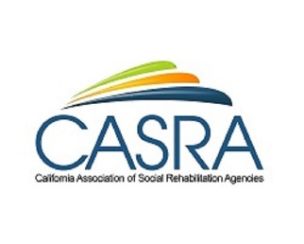
April 14, 2021
11am-noon PST
Are You Talking Like Businesses Think? How to Get More Consumers Hired Doing Remote Job Development
Larry Robbin, CEO, Robbin and Associates
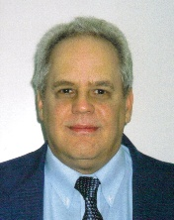
Get businesses to hire from you, using supported work and customized employment. Learn how to speak business language that appeals to the private sector mind set and business people will say yes to your services. Remote job development is possible - learn new techniques for success. Go from basic job development to using private sector sales tactics and get better outcomes with employers.
REGISTER HERE

California Association of Social Rehabilitation Services is pleased to present two free workshops in April!

April 21, 2021
11am-noon PST
Fostering Harm Reduction in Residential Treatment for People who have Co-Occurring Struggles: A Practical Approach
James Roberts, MA, Director of Residential Treatment and Supported Housing Programs, Progress Foundation
The book on Harm Reduction in Residential Treatment has yet to be written. However, harm reduction as a model uniquely fits the framework of Social Rehabilitation. Elements of motivational interviewing, the stages of change model and the context of trauma-informed treatment is the key to developing these interventions. If we focus on transparency instead of judgement, agreements as opposed to rules and flexibility instead of rigidity, supporting client choice as the basis of our practice in our treatment model, a harm reduction philosophy will thrive in the milieu.
REGISTER HERE

